**MEDIA RELEASE**

20 November 2022

**PROFESSOR WHATARANGI WINIATA ACKNOWLEDGED BY THE NATIONAL IWI CHAIR’S FORUM AT RAUKAWA MARAE**

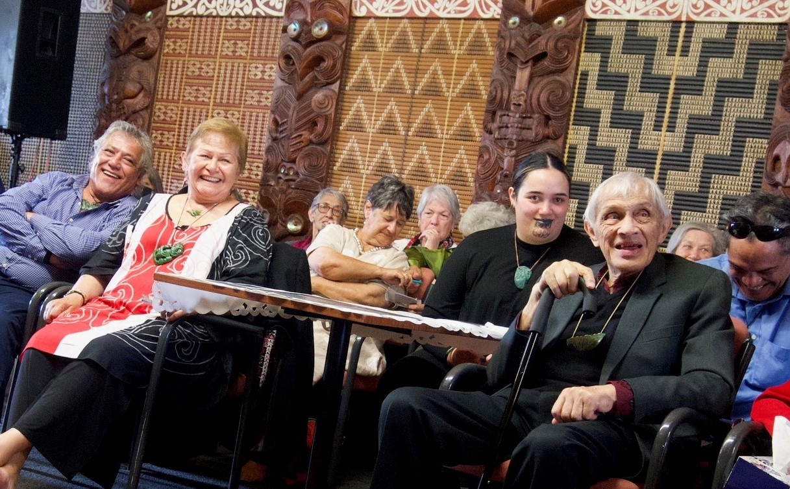

Today the National Iwi Chair's Forum travelled to Raukawa Marae to present the Emeritus Professor Whatarangi Winiata with their Te Whare Pūkenga Award. This living taonga award is bestowed by 86 members of the Forum on Pūkenga who have significantly impacted the lives of whānau, hapū and iwi across Aotearoa.

Te Whare Pūkenga was established by the Iwi Chairs Forum in 2021 to recognise rangatira who have enhanced the lives of all whānau in Aotearoa through their activities. Specifically the award is given to those whose actions contribute significantly to the revitalisation of the Forum’s values including: Rangatiratanga, Whanaungatanga, Manaakitanga, Kaitiakitanga, Tikanga and Pono. Te Whare Pūkenga is an honour that was conceived by, is managed and is completely funded by the 86 Iwi that make up the National Iwi Chairs Forum.

Around 170 whānau and members of the ART Confederation, the majority of whom were kaumātua, as well as others from further afield gathered for the event. Kahurangi Dame [Naida Glavish](https://www.facebook.com/naida.glavish.3?__cft__%5b0%5d=AZWw5FQCmKyjHKhHjW0AfLZlqb-ythL4QRRHxBOBsYCoSm2ov-4vwHjWWRv0Qpy0H5NJxKUqHkkaDBbsWrJNesjNCLg2-e3M4_goHEHE3nxm3Ea_x47-mzXlsqwB3NyElzM&__tn__=-%5dK-R), Ngāti Whatua led the Iwi Chair's delegation and with [Haami Piripi](https://www.facebook.com/haami.piripi?__cft__%5b0%5d=AZWw5FQCmKyjHKhHjW0AfLZlqb-ythL4QRRHxBOBsYCoSm2ov-4vwHjWWRv0Qpy0H5NJxKUqHkkaDBbsWrJNesjNCLg2-e3M4_goHEHE3nxm3Ea_x47-mzXlsqwB3NyElzM&__tn__=-%5dK-R), Te Rarawa Chair, presented the award. In the commendation, the Forum noted that in 1975 Whatarangi initiated the iwi development programme known as Whakatupuranga Rua Mano – Generation 2000, to prepare the ART Confederation (Āti Awa, Ngāti Raukawa and Ngāti Toa Rangatira) for the 21st century. Whatarangi was the architect of the programme’s offspring Te Wānanga o Raukawa.

They acknowledged that over the last 50 years Whatarangi has been an active contributor to his iwi and to Te Ao Māori; holding various positions within the Anglican Church. Whatarangi was part of the Māori team who negotiated the Treaty of Waitangi (Fisheries Claims) Settlement Act in 1992. He is a former member of the New Zealand Māori Council and the Māori Congress. He has been a negotiator on such Treaty issues as state-owned enterprises, broadcasting, radio spectrum, railway lands and fisheries. He served as the inaugural president of the Māori Party from 2004.

Prof. Sir Hirini Moko Mead describes Whatarangi as “a leading thinker of the Māori world, and of te ao Pākehā as well. Someone who set out to improve the wellbeing of Māori in this country, to enlarge the spaces where Māori can be Māori, to decolonise our people and work towards being culturally competent and confident as Māori citizens of our country. Most of all, it was to enable Māori to manage our future ourselves and to run our own affairs without the interference of others.”

In conclusion, Dame Naida said that “Whatarangi's knowledge, skills, dedication and actions have had a significant influence on whānau, hapū and iwi not just within the takiwā of the confederation of Ātiawa, Ngāti Raukawa and Ngāti Toarangatira, but across the nation.”

Piripi Walker of Ngāti Raukawa responded on behalf of the whānau. He thanked in particular the National Iwi Chairs Forum who travelled to present this award. He told the Iwi Leaders who had come to Ōtaki that the iwi were humbled by todays’s visit, and the award itself. He acknowledged the two awards this year, recalling the Award in earlier weeks to Dame Iritana Tawhiwhirangi of Ngāti Porou. He recalled kaumātua from other iwi like Māori Marsden for their teaching, wisdom and guidance to Whatarangi and Francie over the years. He acknowledged the range of organisations and kaupapa that Whatarangi has been involved with. There was laughter, waiata and tears of joy within the whare.

On a more serious note, he acknowledged the support by the Iwi Chairs’ forum of those engaged in advancing the radio spectrum claim and the key role Whatarangi and his hapū had played in laying the groundwork for this kaupapa, which was edging towards fruition.

Helen Leahy, Ngāti Rangi said that “Today Māori have bestowed mana on one of their own in multiple ways. Through tribues and taonga; through the presentation of the award; through the expression of love; through our determination to be present i the spirit of magnificence. If Matua was moved, many of us were totally overwhelmed; feeling the enormity of his contribution; and in awe of his colossal mind and boundless heart.

His grace, his loving leadership and the unequivocal and abundant support of his whānau are precious beyond words. We have been so blessed with their sacrifice, their scholarship and service. Yes indeed, an extraordinary day.”

For more information:

Daphne Luke Piripi Walker

T: 0274 578 713 T: 021 441 9426

E: [daphne@taoni.maori.nz](mailto:daphne@taoni.maori.nz) E: [piripi@reo.co.nz](mailto:piripi@reo.co.nz)